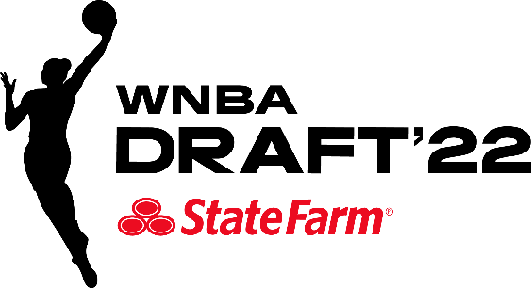

*** MEDIA ADVISORY ***

WHAT: 2022 WNBA Pre-Draft Media Conference Call

WHEN: Thursday, April 7, 2022
2:00 p.m. ET

MEDIA DIAL-IN NUMBER: United States: 888-312-3049
International: +1 323-794-2112

The 2022 WNBA Pre-Draft Media Conference Call will take place Thursday, April 7 at 2:00 p.m. ET. The following participants will provide their thoughts and assessments on teams and prospects, leading into the 2022 WNBA Draft presented by State Farm.

2:00 – 2:45 p.m. ET ESPN Women’s Basketball Analysts
Rebecca Lobo
LaChina Robinson

2:45 – 3:20 p.m. ET WNBA Head Coaches and Basketball Executives
Mike Thibault – Washington Mystics, General Manager and Head Coach
Lin Dunn – Indiana Fever, Interim General Manager
Dan Padover – Atlanta Dream, General Manager/Executive VP of Basketball Operations
Noelle Quinn – Seattle Storm, Head Coach

The WNBA Draft 2022 presented by State Farm® will be held on Monday, April 11. WNBA Commissioner Cathy Engelbert will announce the draft picks live on ESPN with exclusive coverage beginning at 7 p.m. ET. The draft will also be available live on the ESPN App.

Top prospects will take part live as the WNBA Draft presented by State Farm returns to an in-person event for the first time since 2019, with the acclaimed Spring Studios, located in the Tribeca section of New York and the home to such iconic events as Fashion Week and The Tribeca Film Festival, serving as the venue for the evening’s events.

# # #

Contacts: Ron Howard, WNBA Communications, (212) 407-8641 or rhoward@nba.com
Sam Tager, WNBA Communications, (212) 407-8358 or stager@nba.com

