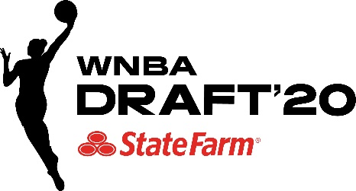

**\*\*MEDIA ADVISORY\*\***

**WNBA Draft 2020 Presented by State Farm®   
Draftee Media Availability**

WNBA Draft 2020 presented by State Farm will be conducted virtually on Friday, April 17.  WNBA Commissioner Cathy Engelbert will announce the draft picks live on ESPN and top prospects will take part remotely.  ESPN’s coverage will begin at 7 p.m. ET and the draft will also be available on the ESPN App.

Each player selected in the first round of the WNBA Draft will have a media conference call after being chosen. The call with the No. 1 overall pick will begin around 7:25 p.m. ET. The schedule for all first-round picks is below, with times subject to change. Select players who are drafted after the first round will be available to media. The timing for these sessions is to be determined.

In addition, the WNBA will distribute video interview highlights of draftees throughout the night.

**WHAT**: WNBA Draftee Media Availability

**WHEN:** Friday, April 17

Beginning at approximately 7:25 p.m. ET

**MEDIA DIAL-IN NUMBER:**  (877) 223-2689

International #: (512) 988-5022

|  |  |
| --- | --- |
| **Player** | **Media Conference Call** |
| No. 1 | 7:25 PM |
| No. 2 | 7:45 PM |
| No. 3 | 8:00 PM |
| No. 4 | 8:15 PM |
| No. 5 | 8:25 PM |
| No. 6 | 8:35 PM |
| No. 7 | 8:45 PM |
| No. 8 | 8:55 PM |
| No. 9 | 9:05 PM |
| No. 10 | 9:15 PM |
| No. 11 | 9:25 PM |
| No. 12 | 9:35 PM |

***\*All times are approximate\****

***\*TBD on select draftee media availability\****