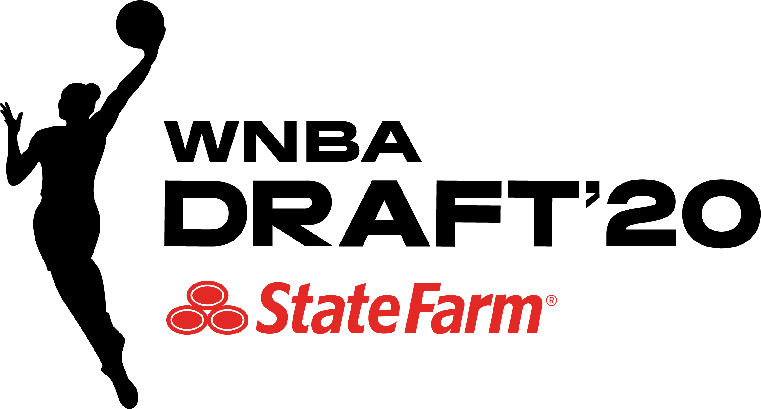

*** MEDIA ADVISORY ***

WHAT: 2020 WNBA Pre-Draft Media Conference Call

WHEN: Monday, April 13, 2019
2:30 p.m. ET

MEDIA DIAL-IN NUMBER: United States: 888-312-3049
International: +1 786-460-7174

The 2020 WNBA Pre-Draft Media Conference Call will take place Monday, April 13 at 2:30 p.m. ET. The following participants will provide their thoughts and assessments on teams and prospects, leading into the 2020 WNBA Draft presented by State Farm.

In light of the COVID-19 pandemic, the WNBA will conduct a virtual draft on Friday, April 17, without players, guests, and media. WNBA Commissioner Cathy Engelbert will announce the draft picks live on ESPN with coverage beginning at 7 p.m. ET, and top prospects will take part remotely. The draft will also be available on the ESPN App.

2:30 – 3:10 p.m. ET ESPN Women’s Basketball Analysts
Rebecca Lobo
Holly Rowe

3:10 – 3:45 p.m. ET WNBA Head Coaches
Greg Bibb – Dallas Wings President and Chief Executive Officer
Sandy Brondello – Phoenix Mercury Head Coach
Walt Hopkins – New York Liberty Head Coach
Cheryl Reeve – Minnesota Lynx General Manager and Head Coach

# # #

Contacts: Ron Howard, WNBA Communications, (212) 407-8641 or rhoward@nba.com
Sam Tager, WNBA Communications, (212) 407-8358 or stager@nba.com

