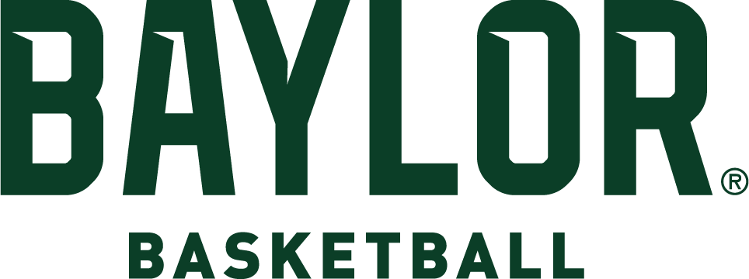

2024-25 ROSTER

# NUMERICAL

|  |  |  |  |  |  |  |  |
| --- | --- | --- | --- | --- | --- | --- | --- |
| **No.** | **Name** | **Pos.** | **Ht.** | **Wt.** | **Cl.** | **Exp.** | **Hometown/High School (Previous College)** |
| 1 | Robert O. Wright III | G | 6-1 | 180 | Fr. | HS | Wilmington, Del./ Montverde Academy |
| 2 | Jayden Nunn | G | 6-4 | 190 | Sr. | 1L | Flint, Mich./Dream City Christian School (VCU) |
| 3 | Jeremy Roach | G | 6-2 | 180 | 5th | TR | Leesburg, Va./St. Paul VI (Duke) |
| 5 | Jason Asemota | F | 6-8 | 205 | Fr. | HS | Lynn, Mass./Hillcrest Prep |
| 7 | VJ Edgecombe | G | 6-4 | 190 | Fr. | HS | Bimini, Bahamas/Long Island Lutheran |
| 11 | Kaleb Jackson | G | 6-2 | 174 | Fr. | HS | Lake Forest, Ill./Carmel Catholic |
| 13 | Langston Love | G | 6-5 | 215 | RJr.^ | 2L | Universal City, Texas/Montverde Academy |
| 15 | Norchad Omier | F | 6-7 | 244 | 5th | TR | Bluefields, Nicaragua/Miami Prep (Fla.) (Miami) |
| 17 | Josh Ojianwuna | F | 6-10 | 255 | Jr. | 2L | Asaba, Nigeria/NBA Global Academy |
| 21 | Davidson Hubbard | G | 6-5 | 216 | Gr. | TR | Charlotte, NC/Ardrey Kell (Hampden-Sydney) |
| 22 | Marino Dubravcic | F | 6-10 | 228 | Fr. | HS | Split, Croatia/Obrtna Technicka |
| 25 | Omar Adegbola | G | 6-4 | 205 | RFr.% | RS | Houston, Texas/Montverde Academy |
| 32 | Jalen Celestine | G | 6-7 | 216 | Gr. | TR | Ajax, Ontario/Long Island Lutheran (California) |
| 41 | Yanis Ndjonga | F | 6-7 | 217 | RSo.% | RS | Yaounde, Cameroon (New Mexico Military Institute) |
| 43 | Cameron Carr | G | 6-5 | 175 | So. | TR | Eden Prairie, Minn/Link Academy (Tennessee) |

**ALPHABETICAL**

|  |  |  |  |  |  |  |  |
| --- | --- | --- | --- | --- | --- | --- | --- |
| **No.** | **Name** | **Pos.** | **Ht.** | **Wt.** | **Cl.** | **Exp.** | **Hometown/High School (Previous College)** |
| 25 | Omar Adegbola | G | 6-4 | 205 | RFr.% | RS | Houston, Texas/Montverde Academy |
| 5 | Jason Asemota | F | 6-8 | 205 | Fr. | HS | Lynn, Mass./Hillcrest Prep |
| 43 | Cameron Carr | G | 6-5 | 175 | So. | TR | Eden Prairie, Minn/Link Academy (Tennessee) |
| 32 | Jalen Celestine | G | 6-7 | 216 | Gr. | TR | Ajax, Ontario/Long Island Lutheran (California) |
| 22 | Marino Dubravcic | F | 6-10 | 228 | Fr. | HS | Split, Croatia/Obrtna Technicka |
| 7 | VJ Edgecombe | G | 6-4 | 190 | Fr. | HS | Bimini, Bahamas/Long Island Lutheran |
| 21 | Davidson Hubbard | G | 6-5 | 216 | Gr. | TR | Charlotte, NC/Ardrey Kell (Hampden-Sydney) |
| 11 | Kaleb Jackson | G | 6-2 | 174 | Fr. | HS | Lake Forest, Ill./Carmel Catholic |
| 13 | Langston Love | G | 6-5 | 215 | RJr.^ | 2L | Universal City, Texas/Montverde Academy |
| 41 | Yanis Ndjonga | F | 6-7 | 217 | RSo.% | RS | Yaounde, Cameroon (New Mexico Military Institute) |
| 2 | Jayden Nunn | G | 6-4 | 190 | Sr. | 1L | Flint, Mich./Dream City Christian School (VCU) |
| 17 | Josh Ojianwuna | F | 6-10 | 255 | Jr. | 2L | Asaba, Nigeria/NBA Global Academy |
| 15 | Norchad Omier | F | 6-7 | 244 | 5th | TR | Bluefields, Nicaragua/Miami Prep (Fla.) (Miami) |
| 3 | Jeremy Roach | G | 6-2 | 180 | 5th | TR | Leesburg, Va./St. Paul VI (Duke) |
| 1 | Robert O. Wright III | G | 6-1 | 180 | Fr. | HS | Wilmington, Del. / Montverde Academy |

^ - sat out 2021-22 as redshirt % - sat out 2023-24 as redshirt

# COACHING STAFF

Head Coach: Scott Drew (Butler, 1993), 22nd season at Baylor (23rd season as Division I head coach) Assistant Coach: Jared Nuness (Valparaiso, 2001), 15th season at Baylor

Assistant Coach: Tweety Carter (Baylor, 2010), third season at Baylor Assistant Coach: Bill Armstrong (UAB, 2001), first season at Baylor Assistant Coach: Steve Henson (Kansas State, 1990), first season at Baylor Assistant Coach: Melvin Hunt (Baylor, 1990), first season at Baylor

Director of Basketball Operations: Ty Beard (Baylor, 2009), seventh season at Baylor General Manager: Jason Smith (Baylor, 2011), fourth season at Baylor

Director of Video Opertaions: Gabe Awbrey (Manhattan Christian College, 2020), first season at Baylor Director of Athletic Performance: Charlie Melton (Memphis, 1998), 22nd season at Baylor

Assistant AD for Athletic Medicine: Dave Snyder (Georgia, 2003), seventh season Assistant Director of Operations: Matt Rodgers (Baylor, 2007), first season

# PRONUNCIATIONS

Omar **ADEGBOLA** AH-deg-bowl-uh

Jason **ASEMOTA** AH-su-MOAT-uh

Jalen **CELESTINE** Cell-LESS-steen

Marino **DUBRAVCIC** Do-BRA-vuh-chich

VJ **EDGECOMBE** EDGE-comb

**YANIS NDJONGA** YAW-nuss JOHN-go

Josh **OJIANWUNA** Oh-JON-woo-nuh

**NORCHAD OMIER** NOR-chad OH-meer