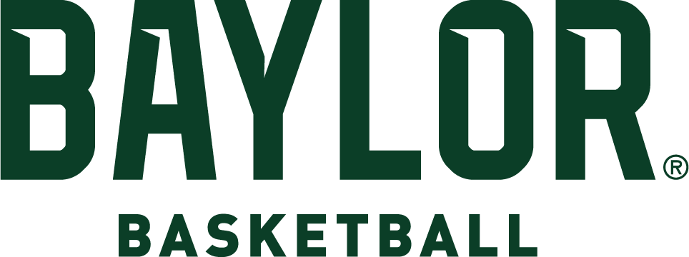

# NUMERICAL

2023-24 ROSTER

|  |  |  |  |  |  |  |  |
| --- | --- | --- | --- | --- | --- | --- | --- |
| **No.** | **Name** | **Pos.** | **Ht.** | **Wt.** | **Cl.** | **Exp.** | **Hometown/High School (Previous College)** |
| 1 | Miro Little | G | 6-4 | 185 | Fr. | HS | Tampere, Finland/Sunrise Christian |
| 2 | Jayden Nunn | G | 6-4 | 190 | Jr. | TR | Flint, Mich./Dream City Christian School (VCU) |
| 4 | Ja’Kobe Walter | G | 6-5 | 195 | Fr. | HS | McKinney, Texas/ Link Academy |
| 10 | RayJ Dennis | G | 6-2 | 185 | RSr. | TR | Plainfield, Ill./Oswego East (Toledo) |
| 11 | Jalen Bridges | F | 6-9 | 225 | Sr. | 1L | Fairmont, W.Va./Fairmont Senior HS (West Virginia) |
| 13 | Langston Love | G | 6-5 | 210 | RFr.^ | 1L | Universal City, Texas/Montverde Academy |
| 15 | Joshua Ojianwuna | F | 6-10 | 230 | So. | 1L | Asaba, Nigeria/NBA Global Academy |
| 20 | Austin Sacks | F | 6-7 | 200 | Sr. | SQ | Los Angeles, Calif./Oakwood HS (Santa Clara) |
| 21 | Yves Missi | F | 7-0 | 235 | Fr. | HS | Yaounde, Cameroon/Prolific Prep |
| 23 | Jonathan Tchamwa Tchatchoua | F | 6-8 | 250 | Gr.% | 3L | Douala, Cameroon/NBA Global Academy - Australia (UNLV) |
| 25 | Omar Adegbola | G | 6-4 | 205 | Fr. | HS | Houston, Texas/Montverde Academy |
| 33 | Caleb Lohner | F | 6-8 | 235 | Sr. | 1L | Flower Mound, Texas/Wasatch Academy (BYU) |
| 41 | Yanis Ndjonga | F | 6-7 | 210 | Jr. | TR | Yaounde, Cameroon (New Mexico Military Institute) |
|  |  |  |  |  |  |  |  |

# ALPHABETICAL

|  |  |  |  |  |  |  |  |
| --- | --- | --- | --- | --- | --- | --- | --- |
| **No.** | **Name** | **Pos.** | **Ht.** | **Wt.** | **Cl.** | **Exp.** | **Hometown/High School (Previous College)** |
| 25 | Omar Adegbola | G | 6-4 | 205 | Fr. | HS | Houston, Texas/Montverde Academy |
| 11 | Jalen Bridges | F | 6-9 | 225 | Sr. | 1L | Fairmont, W.Va./Fairmont Senior HS (West Virginia) |
| 10 | RayJ Dennis | G | 6-2 | 185 | RSr. | TR | Plainfield, Ill./Oswego East (Toledo) |
| 1 | Miro Little | G | 6-4 | 185 | Fr. | HS | Tampere, Finland/Sunrise Christian |
| 33 | Caleb Lohner | F | 6-8 | 235 | Sr. | 1L | Flower Mound, Texas/Wasatch Academy (BYU) |
| 13 | Langston Love | G | 6-5 | 210 | RFr.^ | 1L | Universal City, Texas/Montverde Academy |
| 21 | Yves Missi | F | 7-0 | 235 | Fr. | HS | Yaounde, Cameroon/Prolific Prep |
| 41 | Yanis Ndjonga | F | 6-7 | 210 | Jr. | TR | Yaounde, Cameroon (New Mexico Military Institute) |
| 2 | Jayden Nunn | G | 6-4 | 190 | Jr. | TR | Flint, Mich./Dream City Christian School (VCU) |
| 15 | Joshua Ojianwuna | F | 6-10 | 230 | So. | 1L | Asaba, Nigeria/NBA Global Academy |
| 20 | Austin Sacks | F | 6-7 | 200 | Sr. | SQ | Los Angeles, Calif./Oakwood HS (Santa Clara) |
| 23 | Jonathan Tchamwa Tchatchoua | F | 6-8 | 250 | Gr.% | 3L | Douala, Cameroon/NBA Global Academy - Australia (UNLV) |
| 4 | Ja’Kobe Walter | G | 6-5 | 195 | Fr. | HS | McKinney, Texas/ Link Academy |
|  |  |  |  |  |  |  |  |

% - sat out 2019-20 as redshirt ^ - sat out 2021-22 as redshirt *- Sat out 2022-23 as redshirt

# COACHING STAFF

Head Coach: Scott Drew (Butler, 1993), 21st season at Baylor (22nd season as Division I head coach) Associate Head Coach: Alvin Brooks III (Idaho State, 2002), eighth season at Baylor

Associate Head Coach: John Jakus (Trinity International, 1999), seventh season at Baylor Assistant Coach: Jared Nuness (Valparaiso, 2001), 14th season at Baylor

Special Assistant to the Head Coach: Bill Peterson (Eckerd, 1979), seventh season at Baylor Director of Basketball Operations: Luke Simons (Purdue, 2000), second season at Baylor Director of Video Operations: Ty Beard (Baylor, 2009), sixth season at Baylor

Director of Recruiting Operations: Jason Smith (Baylor, 2011), third season at Baylor Director of Player Personnel: Tweety Carter (Baylor, 2010), second season at Baylor

# PRONUNCIATIONS

Omar **ADEGBOLA** AH-deg-bowl-uh

**RAYJ** Dennis RAY-Jay

John **JAKUS** JAY-kus

**MIRO** Little MEER-oh

**YVES MISSI** EVE MEE-seee

**YANIS NDJONGA** YAW-nuss JOHN-go

Joshua **OJIANWUNA** Oh-JON-woo-nuh Jonathan **TCHAMWA TCHATCHOUA** CHAM-wuh CHA-chew-wuh **JA’KOBE** Walter juh-COBY