*To share:*

February 15, 2020

**Weekend in Waco: *College GameDay* Travels to Baylor for Top Five Matchup Between No. 3 Kansas and No. 1 Baylor**

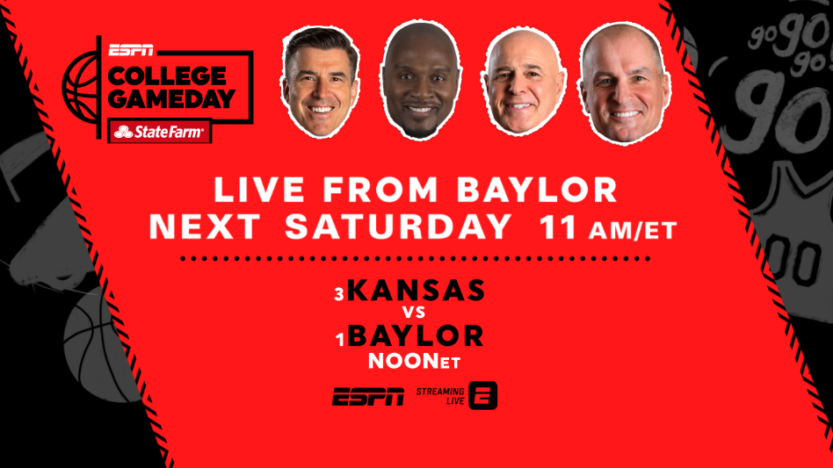*College GameDay Covered by State Farm* is heading to Waco, Texas, next Saturday, Feb. 22, ahead of a top five matchup with No. 3 Kansas facing the top team in the country – No. 1 Baylor. Host [Rece Davis](http://espnmediazone.com/us/bios/davis_rece/) and analysts [Jay Bilas](http://espnmediazone.com/us/bios/bilas_jay/), [LaPhonso Ellis](https://espnpressroom.com/us/bios/laphonso-ellis/) and [Seth Greenberg](http://espnmediazone.com/us/bios/seth-greenberg/) will be live from the Ferrell Center, beginning at 11 a.m. ET on ESPN.

The traveling pregame show will capture all the action leading into the Big 12 showdown, as the Jayhawks prepare to face the Bears at noon, also on ESPN.

This will be Baylor’s second appearance on the show, having hosted one time prior on March 5, 2011. The last school to host *College GameDay* for football and basketball in the same school year (August to May) was Michigan State in 2015-16. The football version of the show went to East Lansing in Week 2 of the 2015 season, while the basketball version of the show was the first of the 2015-16 season.

The *Saturday Primetime presented by H&R Block* matchup, with the commentator crew of Dan Shulman, Bilas and Holly Rowe, will be delivered live in 4K resolution on DIRECTV, Altice and Comcast.

The *College GameDay* site will be announced one-week prior to the show, ensuring visits to sites of top storylines and games appearing on ESPN networks each week.

-30-

Media contact: Anna Negron at [anna.m.negron@espn.com](mailto:anna.m.negron@espn.com) or 860-766-2233; @ItsAnnaNegron